Online Retail Dataset

Dataset Understanding
The Online Retail dataset contains transactional data from an e-commerce platform. It includes fields such as invoice number, stock code, description, quantity, invoice date, unit price, customer ID, and country.
- The dataset is used to analyze:
- Sales performance
- Customer purchasing behavior
- Product demand
- Revenue trends across countries and time periods

Data Cleaning Process
To improve data quality and ensure reliable analysis, the following data preparation steps were performed:
- Addressed missing values by replacing blank Customer IDs with 0 and reviewing missing product descriptions.
- Removed duplicate records to prevent distortion of sales metrics.
- Standardized product descriptions and data formats for consistency.
- Created a Revenue column using the formula:
Revenue = Quantity × Unit Price
- Identified and separated returned/cancelled transactions from completed orders using invoice information and transaction values.
- Investigated negative unit prices and treated invalid records appropriately.
- Validated data types and converted fields where necessary to support accurate analysis and visualization.
The dataset was successfully cleaned and transformed into an analysis-ready format. Key data quality issues such as missing values, duplicates, cancelled orders, and inconsistent records were addressed to improve the accuracy and reliability of the dashboard insights.
EDA
Both(All) |  |  | Positive(completed) |  | Negative(Returned)
Metric | Unit Price | Quantity | Unit Price | Quantity | Unit Price | Quantity
COUNT | 541909 | 541909 | 541907 | 531285 | 2 | 10624
MEAN | 4.611114 | 9.55225 | 4.651957 | 10.65526 | -11062.1 | -45.6072
MEDIAN | 2.08 | 3 | 2.08 | 3 | -11062.1 | 1
MAX | 38970 | 80995 | 38970 | 80995 | -11062.1 | -1
MIN | -11062.1 | -80995 | 0 | 1 | -11062.1 | -80995
STDEVA | 96.75985 | 218.0812 | 94.39545 | 156.8303 | 0 | 1092.214

Key Findings Summary
- The dataset contains 541,909 transactions, with ~98% completed and only ~2% returned, showing strong completion performance.
- Unit price is highly skewed (mean = 4.61 vs median = 2.08), indicating most sales are low-value with a few extreme outliers.
- Completed transactions are stable (mean unit price ≈ 4.65, mean quantity ≈ 10.66), showing normal purchasing behavior.
- Returned transactions contain major data issues, including extreme negative values (e.g., -11,062 unit price and -45 quantity), which distort averages.
- Quantity is highly variable, with very large max values (up to 80,995), suggesting outliers or bulk-order anomalies.
- Overall, the data is heavily skewed with significant outliers and return-data inconsistencies, requiring strong cleaning before deeper analysis.
窗体顶端
Visualizations
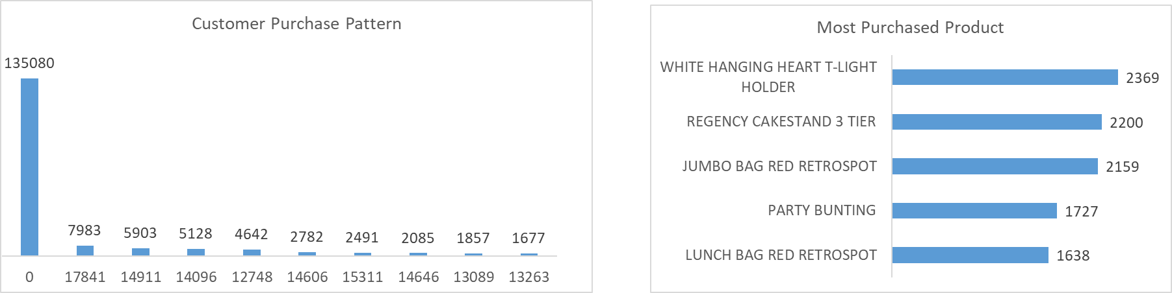
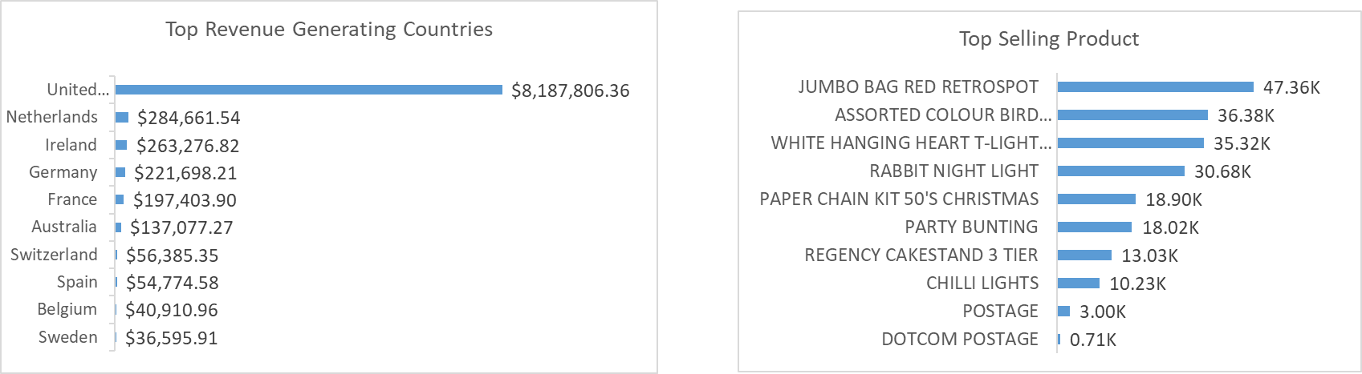
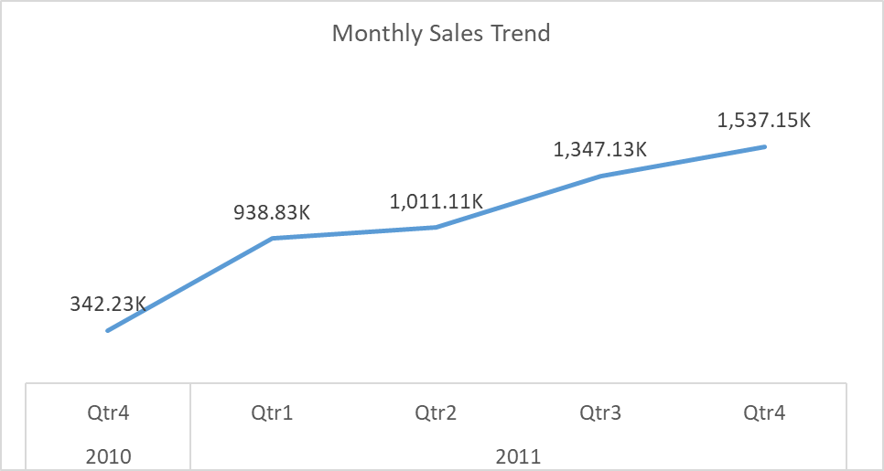

Insights

Product Performance
- JUMBO BAG RED RETROSPOT was the top-selling product by quantity.
- WHITE HANGING HEART T-LIGHT HOLDER was the most frequently purchased item.
- Decorative home and gift products dominated sales.
- A small group of products generated a large share of total revenue, showing a concentrated demand pattern.

Sales Trends
- Revenue showed steady growth across the period.
- Quarterly sales rose from about $342K in late 2010 to over $1.5M by late 2011.
- This indicates sustained demand and positive sales momentum.

Regional Performance
- The United Kingdom accounted for over $8M in revenue, dominating overall sales.
- Other key markets included the Netherlands, Ireland, Germany, and France.
- Heavy reliance on the UK market presents both strength and concentration risk.

Customer Activity

Customer behavior is highly concentrated, with a small group driving a large share of purchases.
- Repeat customers contribute significantly to revenue, indicating strong retention.
- With over 4,000 customers, there is opportunity for deeper segmentation and targeted marketing.

